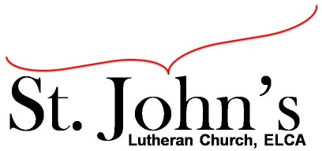A Christ-centered community
welcoming all people and serving God through the Holy Spirit.

As our congregation's leaders, we hear the call to be authentic, affirming, and available.

Special Council Meeting called by Pastor Gary Kinkel – December 2, 2021, at 6:30pm

Council Members present: Pastor Gary Kinkel, Pastor Jerod Freeberg, Jesse Rients,
Erik Vangsness, Mike Laurel, Aimee Johnson, Kirsti Youngs

Council Members absent: Paula Brennan

Call to order: Jesse Rients, 6:35pm

Announcement: Pastor Gary Kinkel –
Pastor Jerod Freeberg has tendered his resignation effective December 22, 2021. He has accepted the Senior Pastor position at St. James Lutheran Church in Crystal, MN, beginning December, 28, 2021.

Motion to accept resignation: Pastor Gary Kinkel / Kirsti Youngs; carried.

Council will help with planning a farewell celebration for Pastor Jerod after worship on Dec. 19.

Motion to adjourn: Pastor Gary Kinkel / Kirsti Youngs; carried 6:47pm.

*Meeting notes taken by Jesse Rients

Respectfully submitted,
Paula Brennan, Council Vice President

Meeting Ground Rules: *Keep it real,* Everyone participates, *Different opinions encouraged,
*Disagree in private, *Unite in public,* Silence is agreement, * Limit side conversations, * Start on time, *Follow through on action plans.

