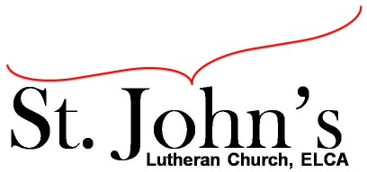A Christ-centered community
welcoming all people and serving God through the Holy Spirit.

As our congregation's leaders, we hear the call to be authentic, affirming, and available.

Council Meeting Agenda for Dec. 15, 2020, at 7:00PM

Council members present: Pastor Gary Kinkel, Pastor Jerod Freeberg, Jesse Rients,
Erik Vangsness, Aimee Johnson, Kirsti Youngs, Mike Laurel, Paula Brennan

I. Gathering
- Call to order 7:04pm, Jess Rients.
- Motion to approve agenda; Pastor Gary Kinkel/Aimee Johnson; carried.
- Scripture and prayer; Pastor Gary Kinkel: The Council in the Word – Acts 15:6-12.

II. Discerning Our Mission
- Drive-in services – Worship at St. John’s, the goal is at least every other week, beginning Jan. 10.
- Building maintenance – Mike Laurel; received invoice for boiler repair $3080.00. Snow removal contract is in place.

III. Giving Thanks -
- Treasurer’s Report – Erik Vangsness; received confirmation PPP loan has been forgiven.
Motion to approve Treasurer’s report: Pastor Jerod Freeberg/Pastor Gary Kinkel; carried.
Motion to draw down remaining $15,000 on the line of credit; Erik Vangsness/Mike Laurel; carried.
- Motion to approve council minutes: Kirsti Youngs/Aimee Johnson; carried.
- Discussion to have special council meeting for Annual Meeting planning.

IV. Sending
- Review action items established – next council meeting date Jan. 18, 2021.
- Closing Prayer – Pastor Gary Kinkel
- Adjournment – Motion to adjourn: Mike Laurel/Pastor Gary Kinkel; carried 8:24pm.

Respectfully submitted,
Paula Brennan, Council Secretary

Meeting Ground Rules: *Keep it real* Everyone participates, *Different opinions encouraged,
*Disagree in private, *Unite in public, * Silence is agreement, * Limit side conversations, * Start on time, *Follow through on action plans.

