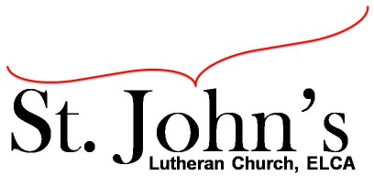A Christ-centered community
welcoming all people and serving God through the Holy Spirit.

As our congregation's leaders, we hear the call to be authentic, affirming, and available.

Council Meeting Agenda for Nov. 17, 2020, at 7:00pm

Council members present: Pastor Gary Kinkel, Pastor Jerod Freeberg, Jesse Rients,
Erik Vangsness, Mike Laurel, Aimee Johnson, Kirsti Youngs, Paula Brennan

I. Gathering
- Call to order: 7:02pm, Jesse Rients
- Motion to approve agenda: Pastor Gary Kinkel/Paula Brennan; carried.
- Scripture and prayer: Pastor Gary Kinkel – The Council in the Word: Acts 15:1-5

II. Discerning Our Mission
- 2020 Mission support – Motion to send $1000 to the synod: Pastor Jerod Freeberg / Pastor Gary Kinkel; carried.
- Sunday school/Confirmation – discussion and ideas to keep students and families more connected and engaged.
- Nominating committee – Motion to add Jim Hime to nominating committee; Pastor Gary Kinkel/Aimee Johnson; carried.
- Snow removal – Motion to hire Loren’s Landscaping for snow removal; Mike Laurel/Kirsti Youngs; carried.
- Boiler replacement – discussion to move forward with boiler repair, Mike Laurel will pursue plans to repair vs. replace. Also $425 is needed for sprinkler replacements.

III. Giving Thanks
- Treasurer’s Report – Erik Vangsness. Motion to approve Treasurer’s Report:
Erik Vangsness/Mike Laurel; carried.
- Motion to approve council minutes; Mike Laurel/Aimee Johnson; carried.

IV. Sending
- Review action items established—next council meeting date Dec. 15, 2020
- Closing Prayer- Pastor Jerod Freeberg
- Adjournment – Motion to adjourn: Erik Vangsness/Kirsti Youngs; 8:51pm carried.

Respectfully submitted,
Paula Brennan, Council Secretary

Meeting Ground Rules: *Keep it real, * Everyone participates, *Different opinions encouraged,
*Disagree in private, *Unite in public, * Silence is agreement, * Limit side conversations, * Start on time, *Follow through on action plans.

