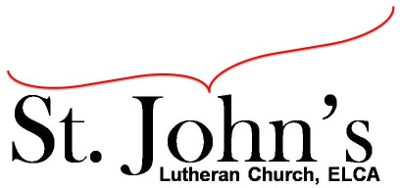A Christ-centered community
welcoming all people and serving God through the Holy Spirit.

As our congregation's leaders, we hear the call to be authentic, affirming, and available.

Council Meeting Agenda for Sept. 22, 2020, at 7:00PM

Council Members Present: Pastor Gary Kinkel, Pastor Jerod Freeberg, Jesse Rients,
Erik Vangsness, Mike Laurel, Aimee Johnson, Kirsti Youngs, Paula Brennan

I. Gathering
- Call to order: 7:05pm, Jesse Rients
- Motion to approve agenda: Pastor Gary Kinkel/Paula Brennan; carried.
- Scripture and prayer: Pastor Gary Kinkel – The Council in the Word: Acts 14:8-20

II. Discerning Our Mission
- Outdoor service update - Will continue every other week weather permitting.
- Costco/Sam’s Club Membership for Loaves & Fishes –
Motion to pay $140.00 for the meal St. John’s hosted on 9/18 for Loaves & Fishes:
Kirsti Youngs/Mike Laurel; carried.
Motion for St. John’s to purchase a Sam’s Club Membership and the Social Concerns Committee can use it and the St. John’s credit card to purchase supplies for Loaves & Fishes once per month, up to $175: Pastor Jerod Freeberg/Jesse Rients; carried.
- Capital Campaign/Stewardship –
Motion to proceed with Eric’s proposal to take a loan to finance the work for repairs to the building/boiler and repay the loan by means of a capital campaign; and invite Walsh and Associates to provide a proposal. Pastor Gary Kinkel/Jesse Rients; carried.

III. Giving Thanks
- Treasurer’s Report – Erik Vangsness
Motion to approve Treasurer’s Report: Pastor Gary Kinkel/Mike Laurel; carried.
- Motion to approve council minutes: Council voted via email and approved August council meeting minutes.

IV. Sending
- Review action items established—next council meeting date Oct. 20, 2020
- Closing Prayer - Pastor Jerod Freeberg
- Adjournment – Motion to adjourn: Mike Laurel/Pastor Gary Kinkel; carried 8:51pm.

Respectfully Submitted,
Paula Brennan, Council Secretary

Meeting Ground Rules: *Keep it real, * Everyone participates, *Different opinions encouraged,
*Disagree in private, *Unite in public, * Silence is agreement, * Limit side conversations, * Start on time, *Follow through on action plans.

