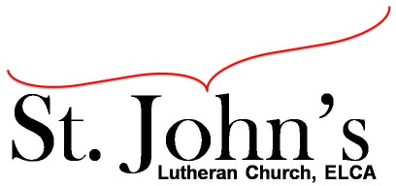A Christ-centered community
welcoming all people and serving God through the Holy Spirit.

As our congregation's leaders, we hear the call to be authentic, affirming, and available.

Council Meeting Agenda for Aug. 17, 2020, at 7:00PM

I. Gathering
- Call to order: Called to order
- Motion to approve agenda: Kirsti, Mike, passed
- Scripture and prayer Pastor Jerod

II. Discerning Our Mission
- Outdoor service update: Discussion, Survey proposed by Kirsti, Jerod will create and send out a survey.
- Toy Corner: Discussion of use of space regarding “The Outcove” and “Mort’s room.”
- Madcap Creative: Short term solution $1,000, Long term Erik will work with a CPA to determine what might be an appropriate amount for St. John’s to pay Madcap Creative on a monthly basis. Erik motion to approve $1,000 for the month of August to Madcap Creative for professional video work; seconded by Kirsti. Vote passed.
- Building expenses: Rooftop AC Unit fixed. Yard equipment discussion resulting in a motion by Kirsti to approve up to $200 for a string trimmer for church yard work, seconded by Aimee. Vote passed. Discussion about chimney repair cost estimated at $10,000 minimum.

III. Giving Thanks
- Treasurer’s Report: Draft report to be voted on by e-mail. Discussion on upcoming maintenance expenses including a new boiler, estimated cost $95,000. Recommendation to begin an effort to raise funds for building maintenance by soliciting private pledges to match donations by the congregation.
- Motion to approve council minutes: Motion made by Mike, seconded by Erik, vote passed.

IV. Sending
- Review action items established—next council meeting date Sept. 15, 2020
- Closing Prayer: Pastor Jerod
- Adjournment: Motion made by Kirsti, seconded by Aimee, vote passed.

Meeting Ground Rules: *Keep it real,* Everyone participates, *Different opinions encouraged,
*Disagree in private, *Unite in public, * Silence is agreement, * Limit side conversations, * Start on time, *Follow through on action plans.

