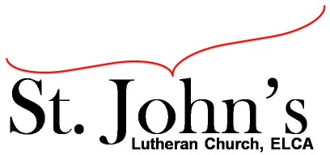A Christ-centered community
welcoming all people and serving God through the Holy Spirit.

As our congregation's leaders, we hear the call to be authentic, affirming, and available.

Council Meeting Agenda for July 20, 2020, at 7:00pm

Council Members present: Pastor Gary Kinkel, Pastor Jerod Freeberg, Jesse Rients,
Erik Vangsness, Mike Laurel, Kirsti Youngs, Aimee Johnson, Paula Brennan

I. Gathering
- Call to order at 7:03 - Jesse Rients
- Motion to approve agenda Pastor Gary Kinkel/Paula Brennan; carried
- Scripture and prayer – Pastor Gary Kinkel, Council in the Word: Acts 13:40-52

II. Discerning Our Mission
- Outdoor service cost and concerns – Lions Park cost is $95, Huber Park is $125, both venues require a reservation for a specific date. We will table pursuing outdoor worship services for now due to spike in COVID-19 cases.
- Small group meetings – Eagle Scout Achievement Honor Court request to be held at St. John’s. As with other small groups, 10 people or less allowed, masks required, social distancing.
- Building expenses – We have received a $600 invoice so far for replacing the fan. More quotes will be gathered before further work is done. Other issues - there is a leak in the basement which Mike Sexton is working to resolve.

III. Giving Thanks
- Treasurer’s Report – Erik Vangsness.
Motion to approve Treasurer’s Report: Pastor Gary Kinkel/Mike Laurel; carried
- Motion to approve council minutes: Pastor Gary Kinkel/Aimee Johnson; carried.

IV. Sending
- Review action items established—next council meeting date August 17, 2020
- Closing Prayer – Pastor Jerod Freeberg
- Adjournment – Motion to adjourn: Mike Laurel/Aimee Johnson; 7:59pm carried.

Respectfully Submitted,
Paula Brennan, Council Secretary

Meeting Ground Rules: *Keep it real,* Everyone participates, *Different opinions encouraged,
*Disagree in private, *Unite in public, * Silence is agreement, * Limit side conversations, * Start on time, *Follow through on action plans.

