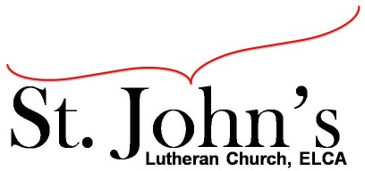A Christ-centered community
welcoming all people and serving God through the Holy Spirit.

As our congregation's leaders, we hear the call to be authentic, affirming, and available.

Council Meeting Agenda for June 16, 2020, at 7:00PM

Council Members present, Pastor Gary Kinkel, Pastor Jerod Freeberg, Jesse Rients,
Erk Vangsness, Mike Laurel, Kirsti Youngs, Aimee Johnson, Paula Brennan

I. Gathering
- Call to order – Jesse Rients, 7:06pm
- Motion to approve agenda – Paula Brennan/Aimee Johnson; carried.
- Scripture and prayer – Pastor Gary Kinkel The Council in the Word: Acts 13:27-39

II. Discerning Our Mission
- Allowing small groups to meet - MWAM has requested to meet. Council will provide guidelines for meeting in groups of 10 or less, wearing masks, distancing, etc.
Outdoor service cost and concerns – Pastor Gary and Pastor Jerod will look at Lions Park and Huber Park as options for holding outdoor worship services.
- SCA & L&F – Will continue to operate using St. John’s lower level.
- Building Issues - HVAC – Mike Laurel is meeting with Associated Mechanical for a quote on repairs and replacement. There is possibility of replacing the fan rather than the entire unit.
- Pastor Gary will officiate a Memorial Service on July 24.

III. Giving Thanks
- Treasurer’s Report – Erik Vangsness has provided a draft; Council will approve final report via email.
- Motion to approve council minutes – Pastor Gary Kinkel/Aimee Johnson; carried.

IV. Sending
- Review action items established—next council meeting date July 20, 2020
- Closing Prayer – Pastor Jerod Freeberg
- Adjournment – Motion to adjourn – Kirsti Youngs/Pastor Gary Kinkel; 8:19pm carried.

Respectfully Submitted,
Paula Brennan, Council Secretary

Meeting Ground Rules: *Keep it real,* Everyone participates, *Different opinions encouraged,
*Disagree in private, *Unite in public, * Silence is agreement, * Limit side conversations, * Start on time, *Follow through on action plans.

