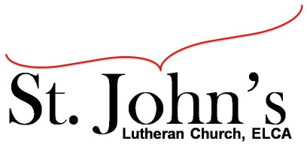A Christ-centered community
welcoming all people and serving God through the Holy Spirit.

As our congregation's leaders, we hear the call to be authentic, affirming, and available.

Special Council Meeting called by Chris Taylor, Council President, May 15, 2022

Council Members present: Pastor Gary Kinkel, Chris Taylor, Erik Vangsness, Annie Rients, Kirsti Youngs, Angel Zollner

Call to order: Chris Taylor, 11:19 a.m.

The Council met to review the agreement and fee schedule to recover the Employee Retention Tax Credit (ERTC) for St. John’s. The Council will need to approve the agreement and the fee schedule.

Motion to approve the agreement and fee schedule with Tax Strategy Pro to recover the Employee Retention Tax Credit: Angel Zollner / Annie Rients; carried

Adjournment – 11:26 a.m.

Respectfully submitted,
Angel Zollner, Council Secretary

