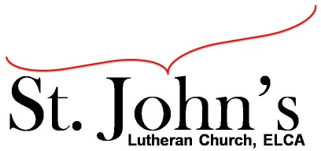A Christ-centered community
welcoming all people and serving God through the Holy Spirit.

As our congregation's leaders, we hear the call to be authentic, affirming, and available.

Council Meeting Agenda for May 19, 2020, at 7:00PM

Council Members present: Pastor Gary Kinkel, Pastor Jerod Freeberg, Jesse Rients,
Erk Vangsness, Mike Laurel, Aimee Johnson, Paula Brennan

Council Members absent: Kirsti Youngs

I. Gathering
- Call to order 7:04pm, Jesse Rients
- Motion to approve agenda: Pastor Jerod Freeberg/Paula Brennan; carried.

II. Discerning Our Mission
- Old National line of credit repayment – Motion to repay line of credit; Pastor Jerod Freeberg/Jesse Rients; carried.
- Executive Committee group gathering recommendation/re-opening - The Executive Committee moves to suspend public gatherings, Council agrees; carried.
- SCA and Loaves & Fishes neighbor concerns - discussion. Pastor Jerod Freeberg and Pastor Gary Kinkel will meet with Lisa to discuss Loaves & Fishes lease.
- Building expenses - emergency lights and kitchen repairs – the stove in the kitchen has been serviced and paid for by an anonymous member. The bid to make repairs is $687 for the occupancy sensors in the 4 restrooms downstairs, an outlet in closet for irrigation, and replacing batteries in emergency lighting rather than replacing bulbs. Motion to accept bid and make repairs: Aimee Johnson/Mike Laurel; carried.

III. Giving Thanks
- Treasurer’s Report – Motion to approve Treasurers Report: Pastor Gary Kinkel/Paula Brennan; carried.
- Motion to approve council minutes: Pastor Jerod Freeberg/Pastor Gary Kinkel; carried.

IV. Sending
- Review action items established - next council meeting date June 16, 2020
- Closing Prayer – Pastor Gary Kinkel
- Adjournment – Motion to adjourn: Paula Brennan/Pastor Gary Kinkel; 7:54pm carried.

Respectfully Submitted,
Paula Brennan, Council Secretary

