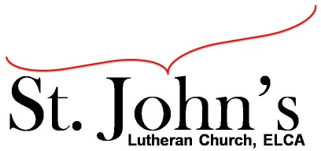A Christ-centered community
welcoming all people and serving God through the Holy Spirit.

As our congregation's leaders, we hear the call to be authentic, affirming, and available.

Council Meeting Agenda for March 15, 2022, at 7:00PM

Council members present: Pastor Gary Kinkel, Chris Taylor, Erik Vangsness, Kirsti Youngs, Annie Rients, Angel Zollner

I. Gathering
- Call to order 7:05pm, Chris Taylor
- Motion to approve agenda: Pastor Gary Kinkel/ Annie Rients; carried
- Motion to approve February council minutes: Annie Rients/Pastor Gary Kinkel; carried
- Scripture and prayer: Pastor Gary Kinkel – The Council in the Word: Acts 18:18-23

II. Discerning Our Mission
Properties update
- Bat removal – a bid has been received from our pest control service to address removal of bats. Properties team has indicated they would be able to undertake some of the items on the bid.
Motion to approve remainder of work be completed by Plunketts Pest Control: Annie Rients/Erik Vangsness; carried.
- Fire Inspections – a bid has been received by Summit Fire Protection to assist with our annual inspection. A portion of the bid includes kitchen hood cleaning. Pastor Gary will explore cost sharing with Loaves & Fishes and Shakopee Community Assistance.
- Education Moving Forward – Annie Rients provided an updated on the Education meeting held on Monday, 3/14/22. The team will continue to meet on Mondays at 7:00 p.m.

III. Giving Thanks
- Filling Council Positions – Erik Vangness will create a description of responsibilities for the Recording Secretary position and have it placed in the bulletin.
- Council Retreat – Annie asked that everyone complete their availability using the online tool.
- IT Proposal – the Council will not move forward with the proposal.

IV. Sending
- Review action items established—next council meeting date April 17, 2022
- Closing Prayer– Pastor Gary Kinkel
- Adjournment – Motion to adjourn; Annie Rients / Pastor Gary Kinkel; carried 8:43 p.m.

Meeting Ground Rules: *Keep it real, * Everyone participates, *Different opinions encouraged,
*Disagree in private, *Unite in public, * Silence is agreement, * Limit side conversations, * Start on time, *Follow through on action plans.

