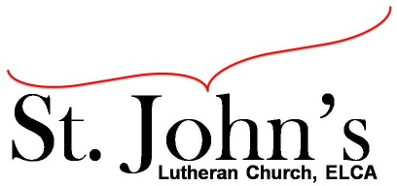A Christ-centered community
welcoming all people and serving God through the Holy Spirit.

As our congregation's leaders, we hear the call to be authentic, affirming, and available.

Council Meeting Agenda for Jan. 19, 2020, at 7:00pm

Council Members present: Pastor Gary Kinkel, Pastor Jerod Freeberg, Jesse Rients,
Mike Laurel, Erik Vangsness, Aimee Johnson, Kirsti Youngs, Paula Brennan

I. Gathering
- Call to order - 7:01pm, Jesse Rients.
- Motion to approve agenda; Pastor Gary Kinkel / Paula Brennan; carried.
- Scripture and prayer - Pastor Gary Kinkel, The Council in the Word, Acts 15:13-21

II. Discerning Our Mission
- Drive-in services – Will have weekly worship services beginning Jan. 31, 2021.
- 2021 budget – Erik Vangsness – Motion to approve proposed 2021 budget; Pastor Gary Kinkel / Kirsti Youngs; carried.
- 2021 PPP loan application – Motion to move forward with application process for second draw of PPP loan; Pastor Gary Kinkel / Mike Laurel; carried.

III. Giving Thanks
- Treasurer’s Report – Motion to approve December Treasurer’s Report; Pastor Gary Kinkel / Aimee Johnson; carried.
- Motion to approve December council minutes – Pastor Gary Kinkel / Mike Laurel; carried.

IV. Sending
- Review action items established - next council meeting date Feb. 16, 2021.
- Closing Prayer – Pastor Jerod Freeberg
- Adjournment – Motion to adjourn; Pastor Gary Kinkel / Erik Vangsness; carried 8:28pm.

Respectfully Submitted,
Paula Brennan, Council Secretary

Meeting Ground Rules: *Keep it real, * Everyone participates, *Different opinions encouraged,
*Disagree in private, *Unite in public, * Silence is agreement, * Limit side conversations, * Start on time, *Follow through on action plans.

