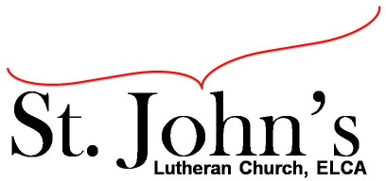A Christ-centered community
welcoming all people and serving God through the Holy Spirit.

As our congregation's leaders, we hear the call to be authentic, affirming, and available.

Council Meeting Agenda for December 21, 2021, at 7:00pm.

Council members present: Pastor Gary Kinkel, Pastor Jerod Freeberg, Jesse Rients,
Mike Laurel, Erik Vangsness, Kirsti Youngs, Paula Brennan

Council members absent: Aimee Johnson

I. Gathering
- Call to order: Jesse Rients – 7:03pm.
- Motion to approve agenda: Pastor Gary Kinkel / Kirsti Youngs; carried.
- Scripture and prayer: Pastor Gary Kinkel – The Council in the Word: Acts 17:16-34

II. Discerning Our Mission
- Building update: Mike Laurel – new water heater has been installed, chimney removal, new liner for chimney wasn’t needed. Some boiler repairs were made, and money saved as expenses were less than anticipated. $4300 is still available for other repairs, safety improvements: emergency gas shut-off, carbon monoxide detector in boiler room, lighting, etc. Sean is interested in pursuing a boiler’s license to maintain the boiler room.
- Pastor Jose Luis is also serving as St. John’s custodial staff.

III. Giving Thanks
- Treasurer’s Report / 2022 Budget: Erik Vangsness – shared preliminary November numbers, council will vote via email to approve November’s final report.
- Motion to approve council minutes: Pastor Gary Kinkel / Kirsti Youngs; carried.

IV. Sending
- Review action items established – next council meeting date January 18, 2021
- Closing Prayer: Pastor Jerod Freeberg
- Adjournment: Motion to adjourn – Kristi Youngs / Pastor Gary Kinkel; carried 8:15pm.

Respectfully submitted,
Paula Brennan, Council Vice President

Meeting Ground Rules: *Keep it real,* Everyone participates, *Different opinions encouraged,
*Disagree in private, *Unite in public, * Silence is agreement, * Limit side conversations, * Start on time, *Follow through on action plans.

