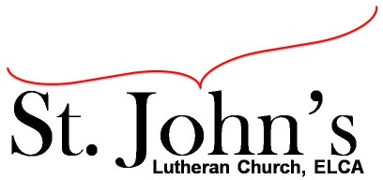A Christ-centered community
welcoming all people and serving God through the Holy Spirit.

As our congregation's leaders, we hear the call to be authentic, affirming, and available.

Council Meeting Agenda for August 17, 2021, at 7:00PM

Council members present: Pastor Gary Kinkel, Jesse Rients, Mike Laurel, Erik Vangsness, Kirsti Youngs, Aimee Johnson, Paula Brennan

Council members absent: Pastor Jerod Freeberg

I. Gathering
- Call to order – Jesse Rients, 7:10pm
- Motion to approve agenda; Pastor Gary Kinkel / Paula Brennan; carried.
- Scripture and prayer – Pastor Gary Kinkel, The Council in the Word: Acts 16:35-40

II. Discerning Our Mission
- Sunday school update – Early worship service for families with children in Sunday school, led by Pastor Jerod Freeberg and music by Brian Johnson.
- Stewardship for all Seasons – The special appeal fundraising campaign has been successful.
- 2022 goals – To purchase basic video equipment and produce daily / weekly mini broadcasts so St. John’s has a regular, recurring, online presence.
Renewing & rebuilding our youth work, including work / updates in the Eagle’s Nest.

III. Giving Thanks
- Treasurer’s Report – council will vote to approve final Treasurer’s Report via email. The two measures voted on August 8 both passed. ELCA Credit Union paperwork is in process, will likely take two weeks. The Endowment Committee is willing to lend $25K at 2.5%, which will leave the line of credit unused.
- Motion to approve council minutes – Pastor Gary Kinkel / Kirsti Youngs; carried.

IV. Sending
- Review action items established—next council meeting date September 21, 2021
- Closing Prayer – Pastor Gary Kinkel
- Adjournment – Motion to adjourn, Pastor Gary Kinkel / Mike Laurel; carried 8:12pm.

Respectfully submitted,
Paula Brennan, Council Vice President

Meeting Ground Rules: *Keep it real,* Everyone participates, *Different opinions encouraged,
*Disagree in private, *Unite in public, * Silence is agreement, * Limit side conversations, * Start on time, *Follow through on action plans.

