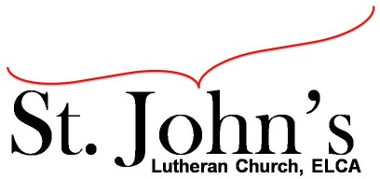A Christ-centered community
welcoming all people and serving God through the Holy Spirit.

As our congregation's leaders, we hear the call to be authentic, affirming, and available.

Council members present: Pastor Gary Kinkel, Pastor Jerod Freeberg, Jesse Rients,
Eric Vangsness, Mike Laurel, Aimee Johnson, Kirsti Youngs, Paula Brennan

Council Meeting Agenda for Feb. 16, 2021, at 7:00pm

I. Gathering
- Call to order – Jesse Rients, 7:04pm
- Motion to approve agenda – Pastor Gary Kinkel / Aimee Johnson; carried.
- Scripture and prayer – Pastor Gary Kinkel – The Council in the Word: Acts 15:22-35

II. Discerning Our Mission
- Drive-in services – continue weekly until warmer weather when we can gather outdoors on the lawn. Looking into a banner for the front of the building promoting drive-in worship, time, online, etc.
- Roof top AC / heat unit replacement –
Motion to hire Associated Mechanical to replace roof top unit and heat as soon as PPP funds are dispersed (not to exceed $8800.00); Mike Laurel / Pastor Gary Kinkel; carried.
- Church Mutual risk reduction – Council has received and reviewed the Church Mutual blog on tips of risk reductions and found that the facilities management team is already executing suggestions.

III. Giving Thanks
- Treasurer’s Report – Erik Vangsness – Council will approve via email when all information is available.
- Motion to approve council minutes – Pastor Gary Kinkel / Kirsti Youngs; carried.

IV. Sending
- Review action items established—next council meeting date Mar. 16, 2021.
- Closing Prayer – Pastor Jerod Freeberg
- Adjournment – Motion to adjourn; Aimee Johnson / Kirsti Youngs; carried 8:16pm.

Respectfully Submitted,
Paula Brennan, Council Vice-President

Meeting Ground Rules: *Keep it real* Everyone participates, *Different opinions encouraged,
*Disagree in private, *Unite in public, * Silence is agreement, * Limit side conversations, * Start on time, *Follow through on action plans.

