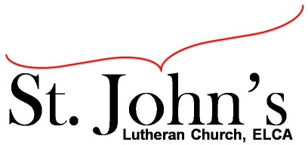A Christ-centered community
welcoming all people and serving God through the Holy Spirit.

As our congregation's leaders, we hear the call to be authentic, affirming, and available.

Special Council Meeting called by Jesse Rients, Council President, January 11, 2022, 7:00pm

Council Members present: Pastor Gary Kinkel, Jesse Rients, Erik Vangsness, Kirsti Youngs, Paula Brennan, Mike Laurel, Aimee Johnson

Call to order: Jesse Rients, 7:05pm

Council discussion regarding vacant Associate Pastor / youth leader role. Members of Council will share update during beginning announcements of Jan. 16 worship service. The following options will be discussed further at the Annual Meeting on January 30. A final decision will be made with input from the congregation and the new, incoming Council.
- Call a part-time pastor (without benefits)
- Hire a student / intern (without benefits)
- Utilize St. John’s resources by hiring a layperson with St. John’s setting the parameters around hours, pay, etc. Provide training for volunteers to perform specific tasks such as teaching Sunday school.

Motion to adjourn: Kirsti Youngs / Paula Brennan; carried 8:32pm.

Respectfully submitted,
Paula Brennan, Council Vice President

Meeting Ground Rules: *Keep it real,* Everyone participates, *Different opinions encouraged,
*Disagree in private, *Unite in public,* Silence is agreement, * Limit side conversations, * Start on time, *Follow through on action plans.

