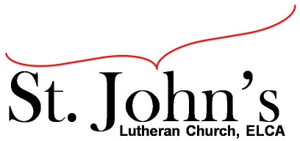A Christ-centered community
welcoming all people and serving God through the Holy Spirit.

As our congregation's leaders, we hear the call to be authentic, affirming, and available.

Special Council Budget Meeting - January 10, 2023, at 6:30 PM

Council members present: Pastor Gary Kinkel, Sandy McCullough, Kirsti Youngs, Erik Vangsness, Annie Rients, Angel Zollner

- Gathering
Call to order 6:33 p.m., Sandy McCullough

- Giving Thanks
- December Treasurer’s Report – Erik Vangsness
Motion to accept December financial reports: Pastor Gary Kinkel / Annie Rients; carried
- Phone System – Erik Vangsness
- Boiler Inspection - Erik Vangsness
- ERTC distribution - Erik Vangsness

- Discerning Our Mission
- Retirement - Pastor Gary announced his retirement, effective the end of March 2023. The council will take steps to prepare for the transition.
- Budget DRAFT Review – Erik Vangsness
- Goals and Projects
- Council Retreat
- Special Music
- Budget Approval
Motion to approve 2023 Budget and present it to the congregation at the Annual Meeting on January 29, 2023: Annie Rients / Pastor Gary Kinkel; carried

- Sending
Motion to adjourn: Angel Zollner / Pastor Gary Kinkel; carried 8:03 p.m.

Respectfully submitted,
Angel Zollner, Council Secretary

Meeting Ground Rules: *Keep it real,* Everyone participates, *Different opinions encouraged,
*Disagree in private, *Unite in public, * Silence is agreement, * Limit side conversations, * Start on time, *Follow through on action plans.

